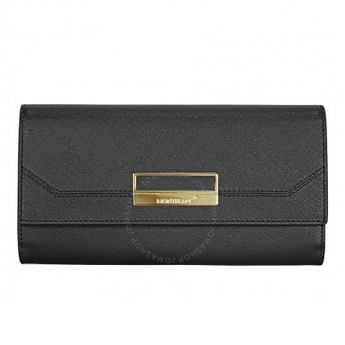

Montblanc Sartorial Saffiano Long Leather Wallet

PRODUCT DETAILS

**A Montblanc Sartorial long wallet crafted in black saffiano leather with gold-tone hardware. This Montblanc wallet features a flap closure, 2 bill pocket, 10 credit**

**card slots, 1 zip coin pocket and an additional slip pocket. Dimensions: 7.4" x 3.9" x 1.1".**